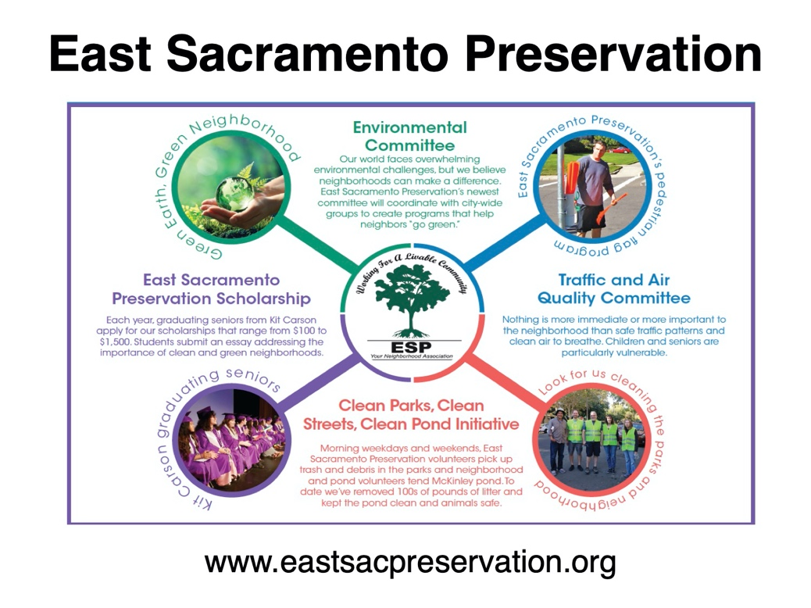

East Sacramento Preservation
Neighborhood Voices Scholarship
Scholarship Application Form 2023-24

Contact: Sandra Carter at (916) 494-8173 or visit eastsacpreservation.org

East Sacramento Preservation (ESP) knows how important it is that local students gain the skills to be our community’s leaders of tomorrow. We are pleased to invite the 2024 graduating seniors from UMOJA International Academy and Hiram W. Johnson High School to apply for the ESP Neighborhood Voices Scholarship.
Three $1,000.00 scholarships will be awarded.

To be considered for these scholarships, a student must:
1. Be a high school senior.
2. Intend to pursue continued community involvement and service.
3. Complete the personal and scholarship sections below.
4. Applied/accepted for and/or enrolled in a community college, university, or vocational school.

Send your scholarship application to the email address on the following page.
Complete application packets must be received by April 15, 2024.

Scholarships will be awarded based on applicant letter, essay, application quality, and community service.

APPLICATION REQUIREMENTS

- APPLICANT PERSONAL INFORMATION AND SIGNATURE

NAME:
DATE OF BIRTH:
HOME ADDRESS:
TELEPHONE NUMBER:
INTENDED COLLEGE OR VOCATION GOAL AND MAJOR:
FUTURE COLLEGE/SCHOOL ADDRESS:
PLANNED CAREER:
E-MAIL ADDRESS:

I AFFIRM THAT ALL STATEMENTS INCLUDED IN THIS SCHOLARSHIP PACKET ARE TRUE, COMPLETE AND CORRECT. I AUTHORIZE THE USE OF MY PHOTO AND ESSAY IN PRESS RELEASES AND INFORMATIONAL POSTING, ONLY IF I AM AWARDED A SCHOLARSHIP.

SIGNATURE. _________________________________________________

DATE:

- COMMUNITY SERVICE/ACTIVITY LIST

Please list the community services/list of activities that you have been involved in during high school.

- APPLICANT PHOTO (ONLY NECESSARY FOR RECIPIENTS OF AWARD)
Please include a head and shoulders photograph of yourself. (A graduation portrait is perfect.) With your permission, the photo will be included with press releases sent to the media announcing award recipients. It may also be used in our own community report publication.

- PERSONAL LETTER FROM APPLICANT

Write a letter directed to the ESP Scholarship Committee describing your community service, your neighborhood, and what you see as important to preserve in your community. The letter should be no more than 150 words.

5. ESSAY

Write an essay that integrates the following topics:

How do you describe your neighborhood? What do you see as important to preserve in a neighborhood? What community are you a part of in your neighborhood? What is the name of an organization you volunteered with? How many hours of service did you complete, and over what period of time were you involved?
Describe the contribution of your community service:
- Did your participation require specific training or planning?
- What did you achieve with your contribution to the community or organization?
- Include details about your participation and any leadership you provided.
- Why did you choose this particular community service?
- What were your goals?
- How did you benefit from your community service?

Technical requirements for the essay
a. 400-600 words
b. Typewritten
c. Double-spaced
d. Grammar/spell check

SEND THE FOLLOWING TO: carters@crc.losrios.edu

- APPLICANT PERSONAL INFORMATION AND SIGNATURE
- COMMUNITY SERVICE/ACTIVITY LIST
- PERSONAL LETTER FROM APPLICANT
4. ESSAY

The material should be in ORDER and emailed to carters@crc.losrios.edu
No paper applications are accepted. Application packets must be received by April 15, 2024.

IF YOU HAVE QUESTIONS, PLEASE CALL (916) 494-8173.
Learn more about our organization at www.eastsacpreservation.org
SAMPLE APPLICATION

Applicant Personal Information and Signature - Example

NAME: Jane L. Doe

DATE OF BIRTH: February 30, 2000

HOME ADDRESS: 2000 River Way, Sacramento, CA 95819

TELEPHONE NUMBER: (916) 000-0000

INTENDED COLLEGE AND MAJOR: Sacramento State University

COLLEGE ADDRESS: Sacramento, CA

VOCATIONAL GOAL: Registered Nurse

E-MAIL ADDRESS: janeldoe@scuds.edu

I AFFIRM THAT ALL STATEMENTS INCLUDED IN THIS SCHOLARSHIP PACKET ARE TRUE, COMPLETE AND CORRECT. I AUTHORIZE THE USE OF MY PHOTO AND ESSAY IN PRESS RELEASES AND INFORMATIONAL POSTING, ONLY IF I AM AWARDED A SCHOLARSHIP.

SIGNATURE: Jane L. Doe

DATE: April 1, 2024

Community Service/Activity List - Example

Volunteer (July – October 2023)
Food for All
Helped with distribution of food to community members; assisted in preparing, selecting and labeling food baskets; organized food deliveries once a week.

Tutor (2023 to present)
Sacramento Learning Program
Assisted students in elementary school programs with learning, reading, and math skills. Motivated students to complete homework assignments

Volunteer (2023 to present)
Sacramento City Library
Assisted members with checking out books, answered general questions, assisted public finding books, returning books, and organizing study area.

Personal Letter - Example

April 1, 2024

East Sacramento Preservation
Sacramento, CA

Dear Scholarship Committee:

My name is Jane L. Doe and I am applying for the 2023 ESP Neighborhood Voices Scholarship. My entire family lives in Sacramento and the Elk Grove area. I would like to become a registered nurse. I plan to live in California, once I graduate from college.

During my second year of high school, I started volunteering in my neighborhood. I wanted to make a difference in my community. I tried different organizations and chose one that I felt most comfortable serving. I enjoyed and learned very much about my community.

While tutoring as a volunteer, I learned that my education could benefit a student who needed some help. And, I learned to listen and be role model for elementary school students. I felt very proud of myself for contributing to my community.

I’m planning to attend Sacramento State College and complete a BS in nursing. Also, I would like to live in Sacramento or any other city in California.

Sincerely,

Jane L. Doe

Essay - Example

At the beginning of my graduating year, I was anxiously looking for places to gain service hours so I could meet my high school graduation requirements. I found that the Sacramento Public Library had a teen-led program to help students K-8 with their homework via Zoom. I thought it was perfect because I could gain service hours from the comfort of my own home, without the anxiety of leaving the house or the inconvenience of someone driving me to the library. I participated in a few workshops with the group of teens that allowed me to gain the skills to interact with students to be prepared for the real sessions.
When I logged into Zoom for my first session, I was somewhat nervous because I would have to interact with kids. Not that I’m afraid of children, I just never considered myself to be good with kids. I volunteered at a camp a few years before and the kids told me to “go away” on multiple occasions, so my likability expectations were low. That mixed with my awkward quirks was enough to make my heart race a little bit.
Shortly after signing in, I was assigned my first student. We went to a breakout room and I gave them a high-pitched “hi”. As soon as they responded the anxiety faded away. The kid was a little goofy and just wanted to figure out how to multiply fractions. I could relate to this kid, math is hard. I used my prior knowledge about math to help guide the student through their worksheet. While we worked we talked and made jokes. When our session was over I felt eager to meet with more students within the community. Sometimes during the sessions I could tell some of the students were really struggling. Not just with work but also life. In the background of the Zoom calls, I could see stressed parents, especially when there were several children living in the home. I remember one incident when one kid was living in their car. I have been fortunate enough to live in a middle class part of Sacramento. It made me more aware of the hectic situations that some students experience, as they are trying to learn. This taught me to be grateful for all the resources I have access to at my school. I was also glad to be of service to students who were in the entirety of Sacramento, since Zoom allowed me to interact with many students outside of my neighborhood.
While this experience began as an attempt to find volunteering hours for my graduation requirements, I have enjoyed my time with the students and I have learned that being an active member of my community is rewarding to both, me and those around me. It made me aware of the challenges that students in my community face. I once thought that it had to be something big and complicated, but I learned that just an hour on Zoom can make an impact in someone's life.

